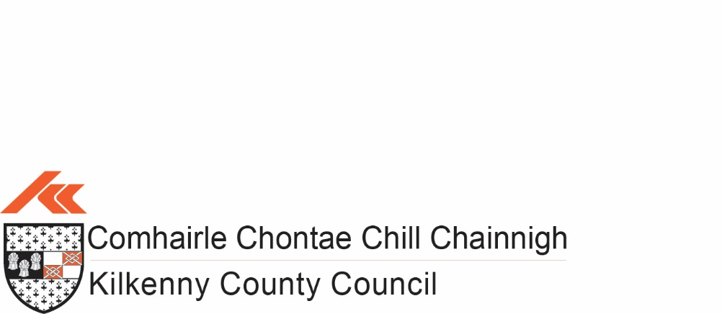
Community Events Grants Scheme 2023
APPLICATION FORM

Closing Date: Friday 24th February, 2023

Completed applications together with supporting documentation must be submitted by post to Ashling Slattery, Community Section, Kilkenny County Council, Johns Green House, Johns Green, Kilkenny.
Telephone: 056-7794488 or Email: ashling.slattery@kilkennycoco.ie

Note: Incomplete applications cannot be considered and will be returned to the applicant

Community Event Grants Scheme 2023
Closing Date Friday 24th February, 2023 at 5.00p.m.
APPLICATION FORM
Purpose of the Scheme:
The main purpose of the Community Event Grants scheme is to provide financial assistance to not for profit groups and organisations engaged in running small scale community events.
Note: INCOMPLETE APPLICATIONS CANNOT BE CONSIDERED
Examples of Eligible Projects
• Field Days – (Not Fundraisers)
• Horse Shows
• Agricultural Shows
• Vintage Rallies
• Historical Society Events
• Arts & Culture Events

Ineligible Listings
• Fundraising Events
• Festivals with attendance of more than 2,500 attendees
• St Patricks Day Events
• Christmas Events
• Transport Costs to attend Events
• Annual Functions E.g. (Club Dinners, Christmas Dinners, Social Nights Out)

PLEASE USE BLOCK LETTERS FOR HAND WRITTEN APPLICATIONS

SECTION 1: CONTACT INFORMATION
Name of the Organisation (Applicant):
Name of Event:
Contact Person:
Your Position in the Organisation:
Correspondence Address:
Telephone Number:
E-mail Address:
Website:
Twitter/Facebook:
SECTION 2: EVENT DETAILS
Please give a brief description of your organisation: -
Details of the Event: -
Name:
Location:
Confirmed Date of Event:
Please give a brief description of the proposed Event:
Describe the anticipated impact/outcome of the event for your community:
Who will be involved in the organising of the Event and what experience do you have in organising events?

Do you have an Event website? | Yes   No 
Please list here:
Note: Please attach the details of your proposed Event Programme
SECTION 3: FUNDING
What is the estimated overall cost of the Event? € _______________ (Please provide at least one quote)

How much are you requesting from the Community Events Scheme? €________________

Are you applying for funding from any other sources? Yes   No 

If YES, please give detail
Source: ______________________________ Amount: €____________

______________________________ Amount: € ____________

If NO, please indicate how you intend to fund the balance of your costs?

Source: ______________________________ Amount: €_____________

______________________________ Amount: € _____________

Note: No double funding from Kilkenny County Council is allowed
SECTION 4: PROJECTED COSTS
Please provide details of proposed costs associated with the project:
Element of Work /Programme/ Item |  | Cost €
Total Cost €
SECTION 5: PARTICIPATION
Recognition must be given to Kilkenny County Council in any promotional material associated with the project. E.g. Promotional Materials, Signage and Social Media. (Kilkenny County Council Logo to be included).
Please state how your organisation proposes to publicly acknowledge Kilkenny County Council’s Community Event Grant contribution?
SECTION 6: SOCIAL INCLUSION
Please outline how you intend to make your event Accessible and Socially Inclusive
DISCLAIMER & DATA PROTECTION:
DISCLAIMER - Kilkenny County Council will not be liable in respect of any loss, damage or costs of any nature arising directly or indirectly from this application or the subject matter of the application.

DATA PROTECTION - Kilkenny County Council collects some personal data during the application and processing of this grant scheme, particularly, names, addresses and contact details (emails and telephone numbers). These details are necessary for the consideration and adjudication on the grants scheme. The grant applications are sometimes shared between relevant County Council Departments for the purpose of supporting the application and also to ensure that similar events are not double funded, and in relation to other festival/events funded by the Council. At all stages the personal data is handled in full accordance with the Data Protection Legislation. Your express consent is required, acknowledging that you understand that you may be submitting personal data.

I/we have read and agree with the above terms and conditions.

Signed: -__________________________________ Date: ____________

Assessment Criteria to be met (for office use only):
No. | Assessment Criteria | Scoring
1. | Community Participation & Benefit | MAX – 30
2. | Evidence of Social Inclusion | MAX – 30
3. | Promoting Healthy Living & Cultural Awareness | MAX – 20
4. | Deliverables e.g.  - Group Track Record  - Capacity & Ability to Deliver | MAX – 20

